7)
Aim:
Basic Spring Boot Application with Spring Data JPA Description:
In this experiment, we will create a Spring Boot application that connects to a MySQL database and uses Spring Data JPA to perform basic database operations. The application will allow inserting and retrieving student records through a RESTful API.
- Student.java – The entity class representing students.
- StudentRepository.java – The JPA repository interface for database operations.
- StudentController.java – REST controller for handling HTTP requests.
- StudentApplication.java – Main application class for bootstrapping the application.
- application.properties – Configuration file for database and server.
- pom.xml – Maven configuration file for dependencies.
Program:

StudentApplication.java
package com.example;
import org.springframework.boot.CommandLineRunner;
import org.springframework.boot.SpringApplication;
import org.springframework.boot.autoconfigure.SpringBootApplication; import org.springframework.context.annotation.Bean;
@SpringBootApplication public class StudentApplication {
public static void main(String[] args) {
SpringApplication.run(StudentApplication.class, args);
}
@Bean
CommandLineRunner initDatabase(StudentRepository repo) { return args -> {
repo.save(new Student(1, "Rakesh kumar")); repo.save(new Student(2, "Murali"));
repo.save(new Student(3, "vamsi"));
System.out.println("Students inserted!");
};
} }
Student.java
package com.example;
import jakarta.persistence.Entity; import jakarta.persistence.Id;
@Entity public class Student {
@Id
private int sno; private String sname;

public Student() {}
public Student(int sno, String sname) { this.sno = sno; this.sname = sname;
}

public int getSno() {
return sno;
}
public void setSno(int sno) {
this.sno = sno;
}
public String getSname() {
return sname;
}
public void setSname(String sname) {
this.sname = sname;
}

}

application.properties
spring.application.name=Student server.port= 9652 spring.datasource.url=jdbc:mysql://localhost:3306/bharathidb spring.datasource.username=root spring.datasource.password= password spring.jpa.hibernate.ddl-auto=create-drop spring.jpa.show-sql=true

StudentController.java
package com.example; import java.util.List;
import org.springframework.web.bind.annotation.GetMapping; import org.springframework.web.bind.annotation.PostMapping; import org.springframework.web.bind.annotation.RequestBody; import org.springframework.web.bind.annotation.RequestMapping; import org.springframework.web.bind.annotation.RestController;

@RestController
//@RequestMapping("/students")
public class StudentController {
private final StudentRepository repo;

public StudentController(StudentRepository repo) { this.repo = repo;
}
//@RequestMapping("/students")
// Add new student
@PostMapping
public Student addStudent(@RequestBody Student student) { return repo.save(student);
}

// Get all students
@GetMapping
public List<Student> getAllStudents() { return repo.findAll();
}

}

StudentRepository.java (Interface)
package com.example;
import org.springframework.data.jpa.repository.JpaRepository; public interface StudentRepository extends JpaRepository<Student, Integer>{ }

pom.xml

<?xml version="1.0" encoding="UTF-8"?> <project xmlns="http://maven.apache.org/POM/4.0.0" xmlns:xsi="http://www.w3.org/2001/XMLSchema-instance" xsi:schemaLocation="http://maven.apache.org/POM/4.0.0 https://maven.apache.org/xsd/maven-4.0.0.xsd">
<modelVersion>4.0.0</modelVersion>
<parent>
<groupId>org.springframework.boot</groupId>
<artifactId>spring-boot-starter-parent</artifactId>
<version>3.5.4</version>
<relativePath/> <!-- lookup parent from repository -->

</parent>
<groupId>com</groupId>
<artifactId>StudentApplication</artifactId>
<version>0.0.1-SNAPSHOT</version>
<name>Student</name>
<description>Demo project for Spring Boot</description>
<url/>

<licenses>
<license/>
</licenses>
<developers>
<developer/>
</developers>

<scm>
<connection/>
<developerConnection/>
<tag/>
<url/>
</scm>

<properties>
<java.version>17</java.version>
</properties>
<dependencies>
<dependency>
<groupId>org.springframework.boot</groupId>
<artifactId>spring-boot-starter-data-jdbc</artifactId> </dependency>

<dependency>
<groupId>org.springframework.boot</groupId>
<artifactId>spring-boot-starter-web</artifactId>
</dependency>

<dependency>
<groupId>com.mysql</groupId>
<artifactId>mysql-connector-j</artifactId>
<scope>runtime</scope>
</dependency>

<dependency>
<groupId>org.springframework.boot</groupId>
<artifactId>spring-boot-starter-test</artifactId>
<scope>test</scope>
</dependency>
<!-- https://mvnrepository.com/artifact/org.springframework.boot/spring-bootstarter-data-jpa -->
<dependency>
<groupId>org.springframework.boot</groupId>
<artifactId>spring-boot-starter-data-jpa</artifactId>
<version>3.5.2</version>
</dependency>

</dependencies>

<build>
<plugins>
<plugin>
<groupId>org.springframework.boot</groupId>
<artifactId>spring-boot-maven-plugin</artifactId>
</plugin>
</plugins> </build> </project>
Output:
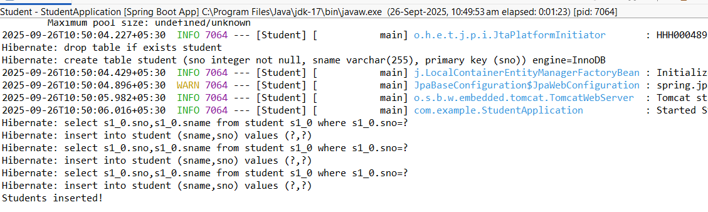

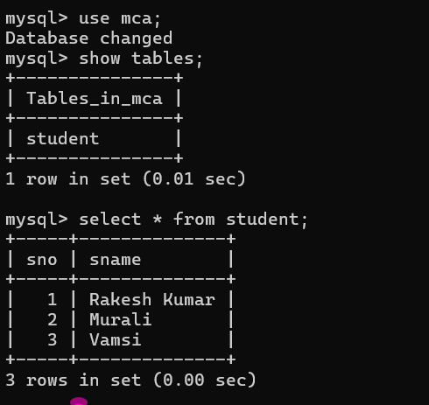

8)
Aim:
Pagination and Sorting in Spring Data JPA Description:
In this experiment, we will create a Spring Boot application that demonstrates how to paginate and sort database records using Spring Data JPA. We will use a Book entity with sample data, a JPA repository interface for database operations, and a REST controller to handle requests. Pagination parameters (page, size) and sorting parameters (sortBy, direction) will be passed via URL query parameters to retrieve data in a paginated and sorted manner.
Program:

application.properties

spring.application.name=Book spring.datasource.url=jdbc:mysql://localhost:3306/new spring.datasource.username=root spring.datasource.password=Satya@123
spring.jpa.hibernate.ddl-auto=create-drop
spring.jpa.show-sql=true
server.port=8846

BookApplication.java

package com.example;

import org.springframework.boot.SpringApplication;
import org.springframework.boot.autoconfigure.SpringBootApplication;

@SpringBootApplication public class BookApplication {

public static void main(String[] args) {
SpringApplication.run(BookApplication.class, args);
}

}

Book.java

package com.example;

import jakarta.persistence.Entity;
import jakarta.persistence.GeneratedValue; import jakarta.persistence.GenerationType; import jakarta.persistence.Id;

@Entity public class Book {
@Id
@GeneratedValue(strategy = GenerationType.IDENTITY) private long id;
private String title;
private String author;

public Book() {}

public Book(String title, String author) { this.title = title;
this.author = author;
}

@Override public String toString() {
return "Book{id=" + id + ", title='" + title + "', author='" + author + "'}";
}

// getters and setters
public Long getId() {
return id;
}
public void setId(Long id) {
this.id = id;
}

public String getTitle() { return title; }
public void setTitle(String title) { this.title = title; }

public String getAuthor() { return author; } public void setAuthor(String author) { this.author = author;
} }
BookRepository (Interface)
package com.example;
import org.springframework.data.jpa.repository.JpaRepository;
public interface BookRepository extends JpaRepository <Book,Long>{
}
BookController.java
package com.example;
import org.springframework.beans.factory.annotation.Autowired; import org.springframework.data.domain.Page;
import org.springframework.data.domain.PageRequest;
import org.springframework.data.domain.Pageable;
import org.springframework.data.domain.Sort;
import org.springframework.web.bind.annotation.*;
@RestController
@RequestMapping("/books")
public class BookController {
@Autowired
private BookRepository bookRepository;
@GetMapping("/init")
public String initData() {
if (bookRepository.count() == 0) {
bookRepository.save(new Book("Spring Boot Basics", "John")); bookRepository.save(new Book("Java Programming", "Alice")); bookRepository.save(new Book("Hibernate in Action","Bob")); bookRepository.save(new Book("Microservices Guide", "Carol")); bookRepository.save(new Book("Data Structures", "Davidraj"));} return "Sample books added!";
}
@GetMapping
public Page<Book> getBooks(
@RequestParam(defaultValue = "0") int page,
@RequestParam(defaultValue = "3") int size,
@RequestParam(defaultValue = "title") String sortBy,
@RequestParam(defaultValue = "asc") String direction
) {
Sort sort = direction.equalsIgnoreCase("asc") ? Sort.by(sortBy).ascending() :
Sort.by(sortBy).descending();
Pageable pageable = PageRequest.of(page, size, sort); return bookRepository.findAll(pageable); }}

pom.xml
<?xml version="1.0" encoding="UTF-8"?> <project xmlns="http://maven.apache.org/POM/4.0.0" xmlns:xsi="http://www.w3.org/2001/XMLSchema-instance" xsi:schemaLocation="http://maven.apache.org/POM/4.0.0 https://maven.apache.org/xsd/maven-4.0.0.xsd">

<modelVersion>4.0.0</modelVersion>

<parent>
<groupId>org.springframework.boot</groupId>
<artifactId>spring-boot-starter-parent</artifactId>
<version>3.5.6</version>
<relativePath/> <!-- lookup parent from repository -->
</parent>

<groupId>com</groupId>
<artifactId>PaginationandSortingApplication</artifactId>
<version>0.0.1-SNAPSHOT</version>
<name>Book</name>
<description>Demo project for Spring Boot</description>

<licenses>
<license/>
</licenses>

<developers>
<developer/>
</developers>

<scm>
<connection/>
<developerConnection/>
<tag/>
<url/>
</scm>

<properties>
<java.version>21</java.version>
</properties>

<dependencies>
<dependency>
<groupId>org.springframework.boot</groupId>
<artifactId>spring-boot-starter-data-jdbc</artifactId>
</dependency>

<dependency>
<groupId>org.springframework.boot</groupId>
<artifactId>spring-boot-starter-web</artifactId>
</dependency>

<dependency>
<groupId>com.mysql</groupId>
<artifactId>mysql-connector-j</artifactId>
<scope>runtime</scope>
</dependency>

<dependency>
<groupId>org.springframework.boot</groupId>
<artifactId>spring-boot-starter-test</artifactId>
<scope>test</scope>
</dependency>

<dependency>
<groupId>org.springframework.boot</groupId>
<artifactId>spring-boot-starter-data-jpa</artifactId>
</dependency>
</dependencies>

<build>
<plugins>
<plugin>
<groupId>org.springframework.boot</groupId>
<artifactId>spring-boot-maven-plugin</artifactId>
</plugin>
</plugins>
</build>

</project>
Output:

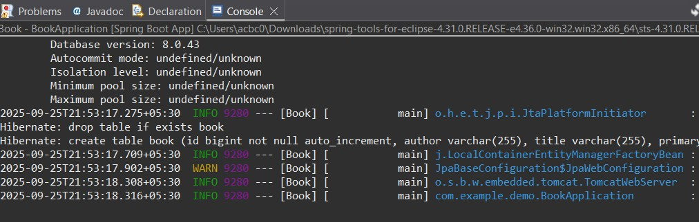

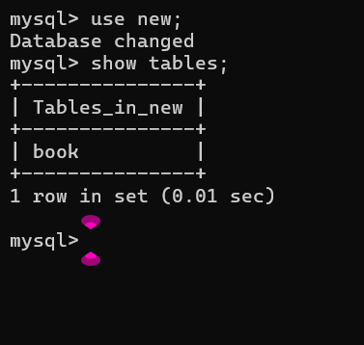

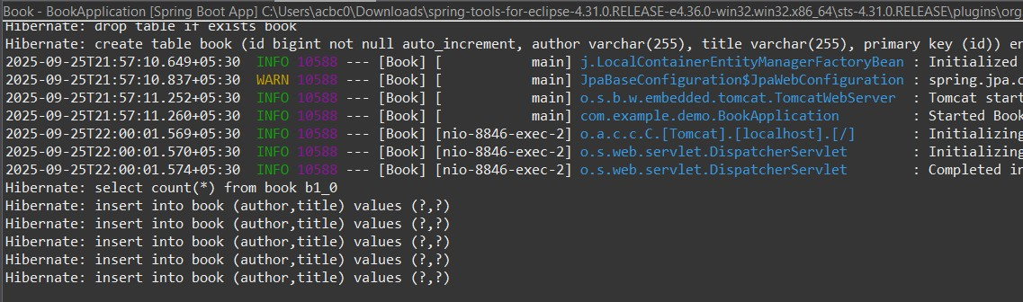

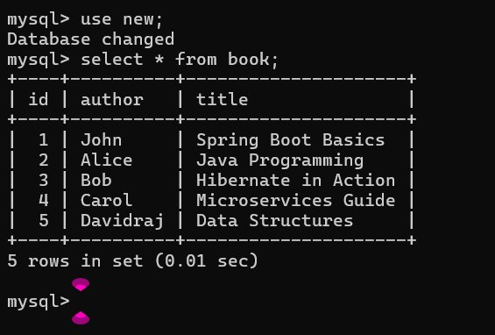

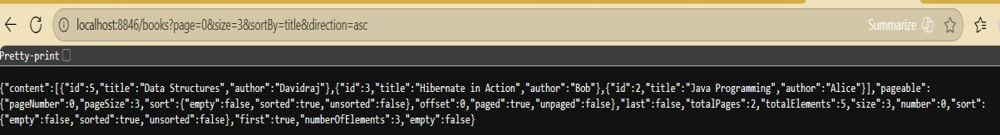

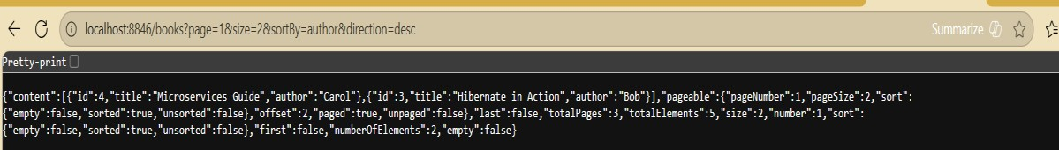

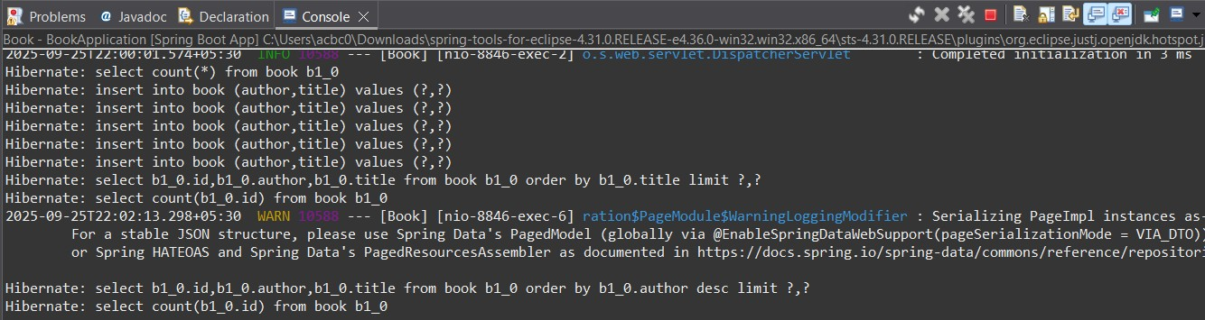

9)
Aim:
Implementing AOP for Logging with Spring Data JPA Description:
In this experiment, we create a Spring Boot application to manage products. The application includes:
- Entity – Product with id, name, and price.
- Repository – ProductRepository for database operations.
- Service – ProductService to handle business logic.
- Controller – ProductController for REST APIs.
- Aspect – LoggingAspect to log method calls in ProductService.
- Database – H2 in-memory DB or MySQL.
- Dependency Management – Managed via Maven (pom.xml).
This demonstrates the use of Spring Data JPA, Spring AOP, and RESTful API development.

Program:

ProductRepository.java (Interface)
Package com.example.demo;
Import org.springframework.data.jpa.repository.JpaRepository;
public interface ProductRepository extends JpaRepository<Product, Long> { }

ProductService.java
package com.example;
import org.springframework.stereotype.Service; import java.util.List;
@Service public class ProductService {
private final ProductRepository repo;
public ProductService(ProductRepository repo) { this.repo = repo;
}
public Product saveProduct(Product product) { return repo.save(product);
}
public List<Product> getAllProducts() { return repo.findAll();
}
}

application.properties spring.application.name=Product
spring.datasource.url=jdbc:mysql://localhost:3306/new
spring.datasource.username=root spring.datasource.password=Satya@123 spring.jpa.hibernate.ddl-auto=create-drop spring.jpa.show-sql=true
server.port=8805

Product.java
package com.example;
import jakarta.persistence.Entity;
import jakarta.persistence.GeneratedValue; import jakarta.persistence.GenerationType; import jakarta.persistence.Id;
@Entity public class Product {
@Id
@GeneratedValue(strategy = GenerationType.IDENTITY)
private long id;
private String name;
private double price;
public Product() {}
public Product(String name, double price) {
this.name = name;
this.price = price;
}
// getters & setters
public Long getId() { return id; }
public void setId(Long id) { this.id = id; } public String getName() { return name; } public void setName(String name) { this.name = name; } public double getPrice() { return price; } public void setPrice(double price) { this.price = price; }
}

ProductController.java package com.example.demo;
Import org.springframework.web.bind.annotation.*; import java.util.List;
@RestController
@RequestMapping("/products") public class ProductController { private final ProductService service; public ProductController(ProductService service) { this.service = service;
}
@PostMapping("/add") public Product addProduct(@RequestBody Product product) { return service.saveProduct(product);
}
@GetMapping("/all") public List<Product> getAllProducts() { return service.getAllProducts();
}
}

LoggingAspect.java package com.example.demo; import org.aspectj.lang.JoinPoint; import org.aspectj.lang.annotation.Aspect; import org.aspectj.lang.annotation.Before; import org.springframework.stereotype.Component;

@Aspect
@Component
public class LoggingAspect {
// Logs before executing any ProductService method
@Before("execution(* com.example.demo.ProductService.*(..))") public void logBefore(JoinPoint joinPoint) {
System.out.println(">>> Entering method: " + joinPoint.getSignature().getName());
}
}

main.java package com.example.demo; import org.springframework.boot.CommandLineRunner; import org.springframework.boot.SpringApplication; import org.springframework.boot.autoconfigure.SpringBootApplication; import org.springframework.context.annotation.Bean;
@SpringBootApplication public class ProductApplication { public static void main(String[] args) {
SpringApplication.run(ProductApplication.class, args);
}
@Bean
CommandLineRunner runner(ProductRepository repo) { return args -> { repo.save(new Product("Laptop", 55000)); repo.save(new Product("Mobile", 20000)); repo.save(new Product("Tablet", 30000)); repo.save(new Product("Mouse", 35000));
};
}
}

pom.xml
<?xml version="1.0" encoding="UTF-8"?> <project xmlns="http://maven.apache.org/POM/4.0.0" xmlns:xsi="http://www.w3.org/2001/XMLSchema-instance" xsi:schemaLocation="http://maven.apache.org/POM/4.0.0 https://maven.apache.org/xsd/maven-4.0.0.xsd">
<modelVersion>4.0.0</modelVersion>
<parent>
<groupId>org.springframework.boot</groupId>
<artifactId>spring-boot-starter-parent</artifactId>
<version>3.5.4</version>
<relativePath/> <!-- lookup parent from repository -->
</parent>
<groupId>com</groupId>
<artifactId>productApplication</artifactId>
<version>0.0.1-SNAPSHOT</version>
<name>Product</name>
<description>Demo project for Spring Boot</description>
<url/>
<licenses>
<license/>
</licenses>
<developers>
<developer/>
</developers>
<scm>
<connection/>
<developerConnection/>
<tag/>
<url/>
</scm>
<properties>
<java.version>21</java.version>
</properties>
<dependencies>
<dependency>
<groupId>org.springframework.boot</groupId>
<artifactId>spring-boot-starter-data-jdbc</artifactId>
</dependency>
<dependency>
<groupId>org.springframework.boot</groupId>
<artifactId>spring-boot-starter-web</artifactId> </dependency>
<dependency>
<groupId>com.mysql</groupId>
<artifactId>mysql-connector-j</artifactId>
<scope>runtime</scope>
</dependency>
<dependency>
<groupId>org.springframework.boot</groupId>
<artifactId>spring-boot-starter-test</artifactId>
<scope>test</scope>
</dependency>
<!-- Spring AOP -->
<dependency>
<groupId>org.springframework.boot</groupId>
<artifactId>spring-boot-starter-aop</artifactId>
</dependency>
<!-- Lombok (optional, just to reduce boilerplate) -->
<dependency>
<groupId>org.projectlombok</groupId>
<artifactId>lombok</artifactId>
<optional>true</optional>
</dependency>
<dependency>
<groupId>org.springframework.boot</groupId>
<artifactId>spring-boot-starter-data-jpa</artifactId>
</dependency>
<!-- H2 Database (in-memory, no need for MySQL setup) -->
<dependency>
<groupId>com.h2database</groupId>
<artifactId>h2</artifactId>
<scope>runtime</scope>
</dependency>
</dependencies>
<build>
<plugins>
<plugin>
<groupId>org.springframework.boot</groupId>
<artifactId>spring-boot-maven-plugin</artifactId>
</plugin>
</plugins>
</build>
</project>

Output:

